fACULTY OF COMPUTER AND INFORMATION SCIENCES, AIN SHAMS UNIVERSITY
Lab 5
Lighting in OpenGL

Objectives:
- Gain a basic understanding of how lighting works
- Be able to specify light sources in OpenGL
- Be able to specify material properties in OpenGL

OVerview
So far, we have been drawing objects by assigning colors arbitrarily with glColor*(). To get more realistic results and a better sense of 3D, we have to simulate how colors are generated in nature and how we observe it. The basic rule is: we see an object when a light ray hits that object and reflects off it to our eyes.
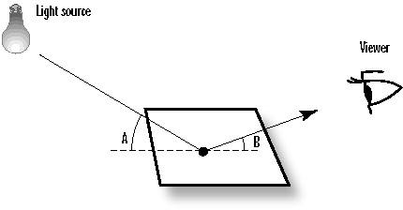
Figure 1: Ingredients of lighting
Simulating the physical laws that govern the lighting process is very complicated and computationally expensive. Due to practical limitations, we do not try to simulate all of the physical principles of light scattering and reflection. For interactivity, OpenGL uses an approximate lighting model that works fairly well and does not take much computing resources.

To use lighting in OpenGL, you have to:
  - define one or more light sources, and
  - specify a material for each primitive drawn that describes how the primitive reflects the incident light

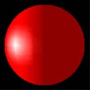
Figure 2: Unlit vs Lit sphere

Types of reflection
The OpenGL lighting model assumes that each surface reflects the incident light in 4 different ways: diffuse, specular, ambient, and emission. As a result, you specify for each material how much light it reflects in each of the 4 reflection types. It might be strange but OpenGL allows you to specify, for each light source, 4 different intensities: one for each type of reflection. The 4 types of reflections are summarized below:
- DIFFUSE - An incoming ray of light is reflected uniformly in all directions. So, you see it the same from any view point. However, once the light radiates from the surface, it does so equally in all directions. It is diffuse lighting that best defines the color of 3D objects.
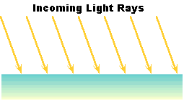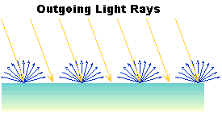
Figure 3: Diffuse scattering
- SPECULAR – Specular reflection is similar to reflections of light off a shiny, mirror-like surface. Specular lighting helps us to distinguish between flat, dull surfaces such as plaster and shiney surfaces like polished plastics and metals.
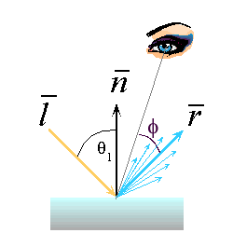
Figure 4: Specular reflection
- AMBIENT – Some of the light rays from a light source undergo multiple reflections from various objects in the surroundings and from light sources that populate the environment before hitting and reflecting off the surface of the observed object. But it would be computationally very expensive to model this kind of light precisely. OpenGL approximates this by the ambient light which is a uniform background light existing everywhere in the scene. Similar to diffuse, the light is reflected off the surface uniformly in all directions.
- EMISSION – The polygon itself emits additional light regardless of the light sources in the scene.
Note that the mathematics OpenGL uses to compute lighting is beyond the scope of the lab handouts.

Defining light sources in OpenGL
OpenGL provides a number of functions for setting up and using light sources, as well as for specifying the surface properties of materials. It can be daunting to absorb all of the many possible variations and details, so we describe the basics here. In this section we discuss how to establish different kinds of light sources in a scene. In the next section we look at ways to characterize the reflective properties of the surfaces of an object.
With OpenGL, you can define up to eight light sources, which are referred to through names GL_LIGHT0, GL_LIGHT1, etc. Each source is invested with various properties, and must be enabled. Each property has a default value. For example, to create a source located at (3, 6, 5) in world coordinates, use:
float myLightPosition[4] = {3.0, 6.0, 5.0, 1.0};
glLightfv(GL_LIGHT0, GL_POSITION, myLightPosition);
glEnable(GL_LIGHTING); // enable
glEnable(GL_LIGHT0); // enable this particular source
The array myLightPosition (use any name you wish for this array) specifies the location of the light source, and is passed to glLightfv() along with the name GL_LIGHT0 to attach it to the particular source GL_LIGHT0. All the properties of light sources can be set using the command glLightfv().
Some sources, such as a desk lamp, are “in the scene”, whereas others, like the sun, are infinitely remote. OpenGL allows you to create both types by using homogeneous coordinates to specify light position:
(x, y, z, 1) | a point light source at the position (x, y, z)
(x, y, z, 0) | a vector to an infinitely remote (directional) light source in the direction (x, y, z)

Infinitely remote light sources are often called “directional”. There are computational advantages to using directional light sources, the light source direction in the calculations of diffuse and specular reflections is constant for all vertices in the scene. But directional light sources are not always the correct choice: some visual effects are properly achieved only when a light source is close to an object.
Besides point and directional light sources, OpenGL allows you to define spot light sources. Like point sources, a spot light source has a finite position. On the other hand, it emits light in a restricted range of directions, known as the cut-off cone. OpenGL allows you to define the direction of the axis of the cone (d), as well as the cut-off angle (c), as seen in figure 5. No light is seen at points lying outside the cutoff cone. For vertices that lie inside the cone, such as P, the amount of light reaching it diminishes/attenuated by the factor cos^{ε} (b ) where b is the angle between d and a line from the source to P, and ε is an exponent chosen by the user to give the desired fall-off of light with angle. The cut-off angle c is by default 180 degrees, meaning the light source is a point source. To make it a spot light source, you have to set c with a value between 0 and 90.
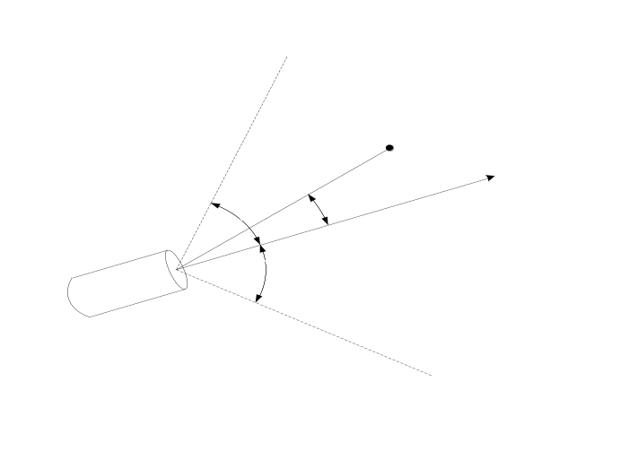
Figure 5: A spot Light SOurce emits light in a limited cone of directions
OpenGL also allows you to specify how rapidly light diminishes with distance from a source. OpenGL attenuates the strength of a positional light source by the following attenuation factor:
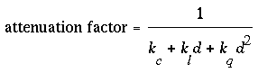
where k_{c}, k_{l}, and k_{q} are coefficients and d is the distance between the light’s position and the vertex receiving the light. OpenGL allows you to set the values of the 3 coefficients k_{c}, k_{l}, and k_{q}.
The command used to specify all properties of lights is glLight{if}[v](light, pname, param), where
Light | refers to the light source being modified. It can be either GL_LIGHT0, GL_LIGHT1, …, or GL_LIGHT7.
Pname | refers to the characteristic of the light being set. It can be any of the named parameters given in table 1.
Param | indicates the values to which the pname characteristic is set. It can be an array of values if you are calling the vector version glLight{if}v (). If you the suffix v is dropped, it should be a single value.

Table 1
Parameter Name | Default Value | Meaning
GL_AMBIENT | (0.0, 0.0, 0.0, 1.0) | ambient RGBA intensity of light
GL_DIFFUSE | (1.0, 1.0, 1.0, 1.0) | diffuse RGBA intensity of light
GL_SPECULAR | (1.0, 1.0, 1.0, 1.0) | specular RGBA intensity of light
GL_POSITION | (0.0, 0.0, 1.0, 0.0) | (x, y, z, w) position of light (note that OpenGL transforms it using the model-view transformation)
GL_SPOT_DIRECTION | (0.0, 0.0, -1.0) | (x, y, z) direction of spotlight (note that OpenGL transforms it using the model-view transformation)
GL_SPOT_EXPONENT | 0.0 | spotlight exponent
GL_SPOT_CUTOFF | 180.0 | spotlight cutoff angle
GL_CONSTANT_ATTENUATION | 1.0 | constant attenuation factor
GL_LINEAR_ATTENUATION | 0.0 | linear attenuation factor
GL_QUADRATIC_ATTENUATION | 0.0 | quadratic attenuation factor

The default values listed for GL_DIFFUSE and GL_SPECULAR in table 1 apply only to GL_LIGHT0. For other lights, the default value is (0.0, 0.0, 0.0, 1.0) for both GL_DIFFUSE and GL_SPECULAR.
Remember to turn on each light GL_LIGHTi with glEnable(GL_LIGHTi) so that it works correctly.

Defining Material Properties
The material properties define how the surface of the primitive reflects the incident light. This section describes how to define the material properties of the objects in the scene: the ambient, diffuse, and specular colors, the shininess, and the emission color. Most of the material properties are conceptually similar to ones you have already used to create light sources. However, they carry a different meaning. For example, the diffuse color (r, g, b, a) of a light source defines the intensity of the red, green, blue (and alpha) light components emitted by the light source. The diffuse color (r, b, b, a) that you set for a material defines the proportion of the incident red, green, blue, and alpha light components that are reflected by the primitive to be drawn.
All material properties can be set using the command glMaterial{if}[v](face, pname, param), where

Face | can be GL_FRONT, GL_BACK, or GL_FRONT_AND_BACK to indicate which face of the object the material should be applied to. A primitive is front-facing when its vertices appear to the camera in a counter-clockwise order. Otherwise, the primitive is back-facing. OpenGL allows you to put different material to front- and back-facing primitives.
Pname | refers to the particular material property being set.
Param | is the desired values for that property, which is either an array of values (if the vector version is used) or the actual value (if the nonvector version is used). The nonvector version works only for setting GL_SHININESS. The possible values for pname are shown in table 2. Note that GL_AMBIENT_AND_DIFFUSE allows you to set both the ambient and diffuse material colors simultaneously to the same RGBA value.

Table 2
Parameter Name | Default Value | Meaning
GL_AMBIENT | (0.2, 0.2, 0.2, 1.0) | ambient color (reflection coefficients) of material
GL_DIFFUSE | (0.8, 0.8, 0.8, 1.0) | diffuse color (reflection coefficients) of material
GL_AMBIENT_AND_DIFFUSE | N/a | Sets the ambient and diffuse color (reflection coefficients) of material to the provided color value. Naturally, a material has the same color (looks the same) regardless of whether the incident light is directly emitted from a light source or is an ambient light. That is why we usually set both the ambient and diffuse to the same color.
GL_SPECULAR | (0.0, 0.0, 0.0, 1.0) | specular color (reflection coefficients)of material.
GL_SHININESS | 0.0 | specular exponent. It controls the size and brightness of the specular highlight. You can assign a number in the range of [0.0, 128.0] to GL_SHININESS - the higher the value, the smaller and brighter (more focused) the highlight
GL_EMISSION | (0.0, 0.0, 0.0, 1.0) | emissive color intensities of material

Note that diffuse reflectance plays the most important role in determining what you perceive the color of an object to be.

Lighting Demo
Now, we show how to modify the program we have been developing in the previous labs so that lighting is used. We assume that you have a running 3D OpenGL program capable of displaying 3D GLUT shapes.
Let’s state first what we want to draw. The scene we shall draw consists of four 3D GLUT shapes placed at the corners of 80x80 square on the x-z plane, centered at the origin. The corner points are (-40, 0, -40), (-40, 0, 40), (40, 0, 40), and (40, 0, -40). To use lighting, we have to define the light sources, and the material properties. We shall put a spot light source at the origin directed along the vector (1, 0, 0). We shall animate the spot source by letting it orbit itself at 180 degrees per second. The color properties of the material and light source are indicated in the code blocks.
Let’s do it in a top-down approach. The setting-up of light sources should be made before any primitive is drawn inside the paint handler. So, we call SetLights() (to be implemented later) just after loading the viewing transformation. Then, we call RenderScene() (to be implemented later) after SetLights().
void OnDisplay() {
//set the background color to black
glClearColor(0, 0, 0, 1);
glClear(GL_COLOR_BUFFER_BIT | GL_DEPTH_BUFFER_BIT);

SetTransformations();

SetLights();
RenderScene();

glFlush();
glutSwapBuffers();
Update();
glutPostRedisplay();
}
If you try to compile the program now, it will complain that SetLights() and RenderScene() are undefined. So, we define SetLights() in a way that agrees with the requirements set forth. SetLights(), which is given below, has been commented so that it is easy to understand.
The variable spotAngle must be defined as a global variable, initialized with a suitable value (say 0), and updated in Update()as follows:
void SetLights() {
glEnable(GL_LIGHTING);

glEnable(GL_LIGHT0);

//color properties
float light0_diffuse[4] = { 1, 1, 1, 1 };
float light0_ambient[4] = { 0.15f, 0.15f, 0.15f, 1 };
float light0_specular[4] = { 1, 1, 1, 1 };

//other properties
float light0_pos[4] = { 0, 0, 0, 1 }; //w=1 --> not directional
float light0_spot_cutoff = 30;
float light0_spot_direction[3] = { 1, 0, -1 };
float light0_spot_exponent = 5;

glLightModelfv(GL_LIGHT_MODEL_AMBIENT, light0_ambient);

//pass OpenGL the light source color values
glLightfv(GL_LIGHT0, GL_DIFFUSE, light0_diffuse);
glLightfv(GL_LIGHT0, GL_AMBIENT, light0_ambient);
glLightfv(GL_LIGHT0, GL_SPECULAR, light0_specular);

//spot light properties
glLightf(GL_LIGHT0, GL_SPOT_CUTOFF, light0_spot_cutoff);

glLightf(GL_LIGHT0, GL_SPOT_EXPONENT, light0_spot_exponent);

//Similar to primitive rendering, the light positions and
//directions are multiplied by the model-view transformation
//(but no projection). So, we can animate light sources as well!
glPushMatrix();
{
//let the spot light source "yaw" about itself
glRotatef(spotAngle, 0, 1, 0);
glLightfv(GL_LIGHT0, GL_POSITION, light0_pos);
glLightfv(GL_LIGHT0, GL_SPOT_DIRECTION, light0_spot_direction);
}
glPopMatrix();
}
/*** Global Variables ***/
UINT prevFrameTime = 0;
float teapotSize = 10;
float spotAngle = 0;
.
.
.
void Update() {
.
.
.
float dt = (currTime - prevFrameTime)/1000.0;
//...........................
//Write all update code here.
//...........................
spotAngle += 0.5;
prevFrameTime = currTime;
.
.
.
}
The implementation of RenderScene()is essentially straightforward, except that it calls a function SetMaterial() (to be defined shortly) to set the material to use in rendering the 3D GLUT shapes. Here is RenderScene():
void RenderScene() {
SetMaterial();
//render solid teapot: far left corner
glPushMatrix();
{
glTranslatef(-40, 0, -40);
glutSolidTeapot(teapotSize);
}
glPopMatrix();

//render solid sphere: near left corner
glPushMatrix();
{
glTranslatef(-40, 0, 40);
glutSolidSphere(teapotSize, 20, 20);
}
glPopMatrix();

//render solid cylinder (cone): near right corner
glPushMatrix();
{
glTranslatef(40, 0, 40);
glutSolidSphere(teapotSize / 2, 20, 2);
}
glPopMatrix();

//render solid torus: far right corner
glPushMatrix();
{
glTranslatef(40, 0, -40);
glutSolidTorus(teapotSize / 2, teapotSize * 2, 20, 20);
}
glPopMatrix();
}
Finally, we define a red-looking shiny material in SetMaterial() as follows:
void SetMaterial()
{
/**
* We want to make objects to look red. So, the diffuse of the material must be
* set to red. We want the objects to be shiny. So, we set the material's specular
* color to r = g = b = high value, and set its shininess to a high value less
* than or equal to 128. We do not want emission. So, we set to black.
**/
//red material -> diffuse = red
float mat0_diffuse[4] = { 1, 0, 0, 1 };
//Naturally, the material reflects the same amount of incident light, either it is
//direct light (diffuse) or background light (ambient). So, we usually take
//the ambient = the diffuse of the material
float mat0_ambient[4] = { 1, 0, 0, 1 };
//Naturally, the specular of the material is a shade(scale) of white. r = g = b = const
//If the material is shiny, const -> 1. If the material is dull, const -> 0.
float mat0_specular[4] = { 0, 1, 0, 1 };

float mat0_shininess = 80;
float mat0_emission[4] = { 0, 0, 0, 1 };

//ambient of the material usually equals its diffuse
//glMaterialfv(GL_FRONT_AND_BACK, GL_AMBIENT_AND_DIFFUSE, mat0_diffuse);

glMaterialfv(GL_FRONT_AND_BACK, GL_DIFFUSE, mat0_diffuse);
glMaterialfv(GL_FRONT_AND_BACK, GL_AMBIENT, mat0_ambient);

glMaterialfv(GL_FRONT_AND_BACK, GL_SPECULAR, mat0_specular);
glMaterialf(GL_FRONT_AND_BACK, GL_SHININESS, mat0_shininess);

glMaterialfv(GL_FRONT_AND_BACK, GL_EMISSION, mat0_emission);
}

